Problem 1

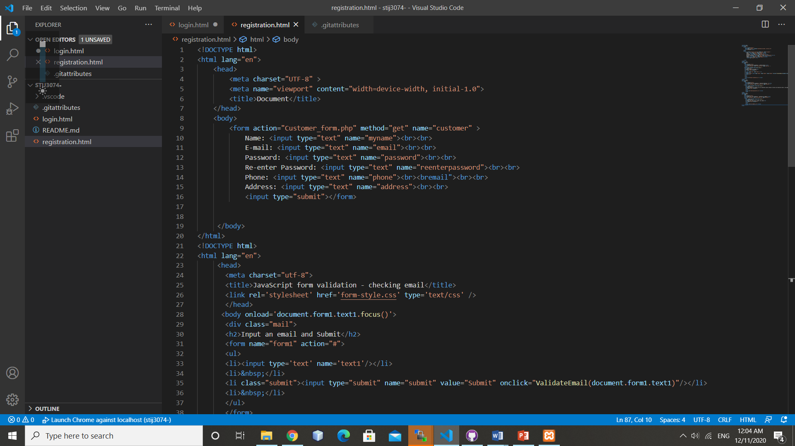

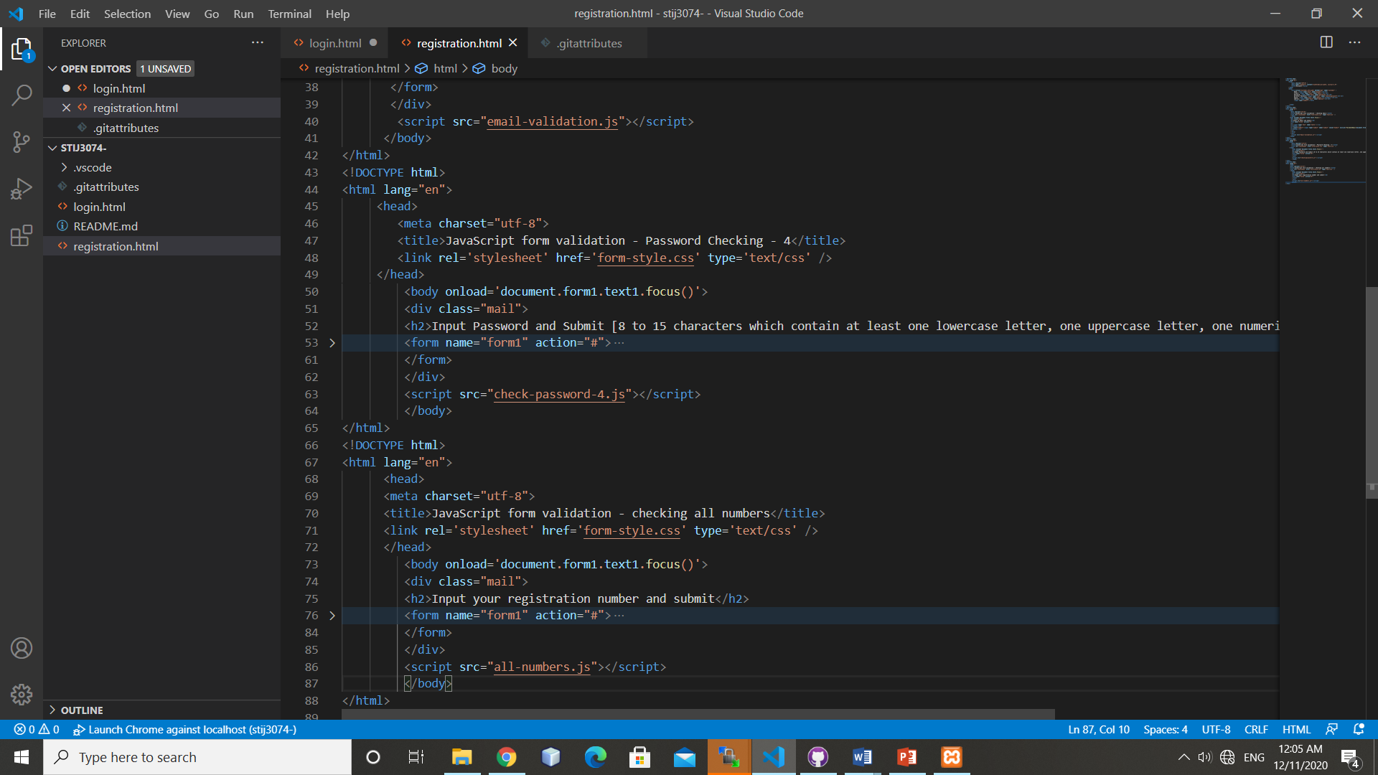

<!DOCTYPE html>

<html lang="en">

    <head>

        <meta charset="UTF-8" >

        <meta name="viewport" content="width=device-width, initial-1.0">

        <title>Document</title>

    </head>

    <body>

        <form action="Customer_form.php" method="get" name="customer" >

            Name: <input type="text" name="myname"><br><br>

            E-mail: <input type="text" name="email"><br><br>

            Password: <input type="text" name="password"><br><br>

            Re-enter Password: <input type="text" name="reenterpassword"><br><br>

            Phone: <input type="text" name="phone"><br><bremail"><br><br>

            Address: <input type="text" name="address"><br><br>

            <input type="submit"></form>

     </body>

</html>

<!DOCTYPE html>

<html lang="en">

     <head>

       <meta charset="utf-8">

       <title>JavaScript form validation - checking email</title>

       <link rel='stylesheet' href='form-style.css' type='text/css' />

       </head>

      <body onload='document.form1.text1.focus()'>

       <div class="mail">

       <h2>Input an email and Submit</h2>

       <form name="form1" action="#">

       <ul>

       <li><input type='text' name='text1'/></li>

       <li>&nbsp;</li>

       <li class="submit"><input type="submit" name="submit" value="Submit" onclick="ValidateEmail(document.form1.text1)"/></li>

       <li>&nbsp;</li>

       </ul>

       </form>

       </div>

        <script src="email-validation.js"></script>

      </body>

</html>

<!DOCTYPE html>

<html lang="en">

     <head>

        <meta charset="utf-8">

        <title>JavaScript form validation - Password Checking - 4</title>

        <link rel='stylesheet' href='form-style.css' type='text/css' />

     </head>

         <body onload='document.form1.text1.focus()'>

         <div class="mail">

         <h2>Input Password and Submit [8 to 15 characters which contain at least one lowercase letter, one uppercase letter, one numeric digit, and one special character]</h2>

         <form name="form1" action="#">

<ul>

<li><input type='text' name='text1'/></li>

<li class="rq">*Enter numbers only.</li>

<li>&nbsp;</li>

<li><input type="submit" name="submit" value="Submit" onclick="allnumericplusminus(document.form1.text1)" /></li>

<li>&nbsp;</li>

</ul>

         </form>

         </div>

         <script src="check-password-4.js"></script>

         </body>

</html>

<!DOCTYPE html>

<html lang="en">

      <head>

      <meta charset="utf-8">

      <title>JavaScript form validation - checking all numbers</title>

      <link rel='stylesheet' href='form-style.css' type='text/css' />

      </head>

         <body onload='document.form1.text1.focus()'>

         <div class="mail">

         <h2>Input your registration number and submit</h2>

         <form name="form1" action="#">

<ul>

<li><input type='text' name='text1'/></li>

<li class="rq">*Enter numbers only.</li>

<li>&nbsp;</li>

<li><input type="submit" name="submit" value="Submit" onclick="allnumeric(document.form1.text1)" /></li>

<li>&nbsp;</li>

</ul>

         </form>

         </div>

         <script src="all-numbers.js"></script>

         </body>

</html>

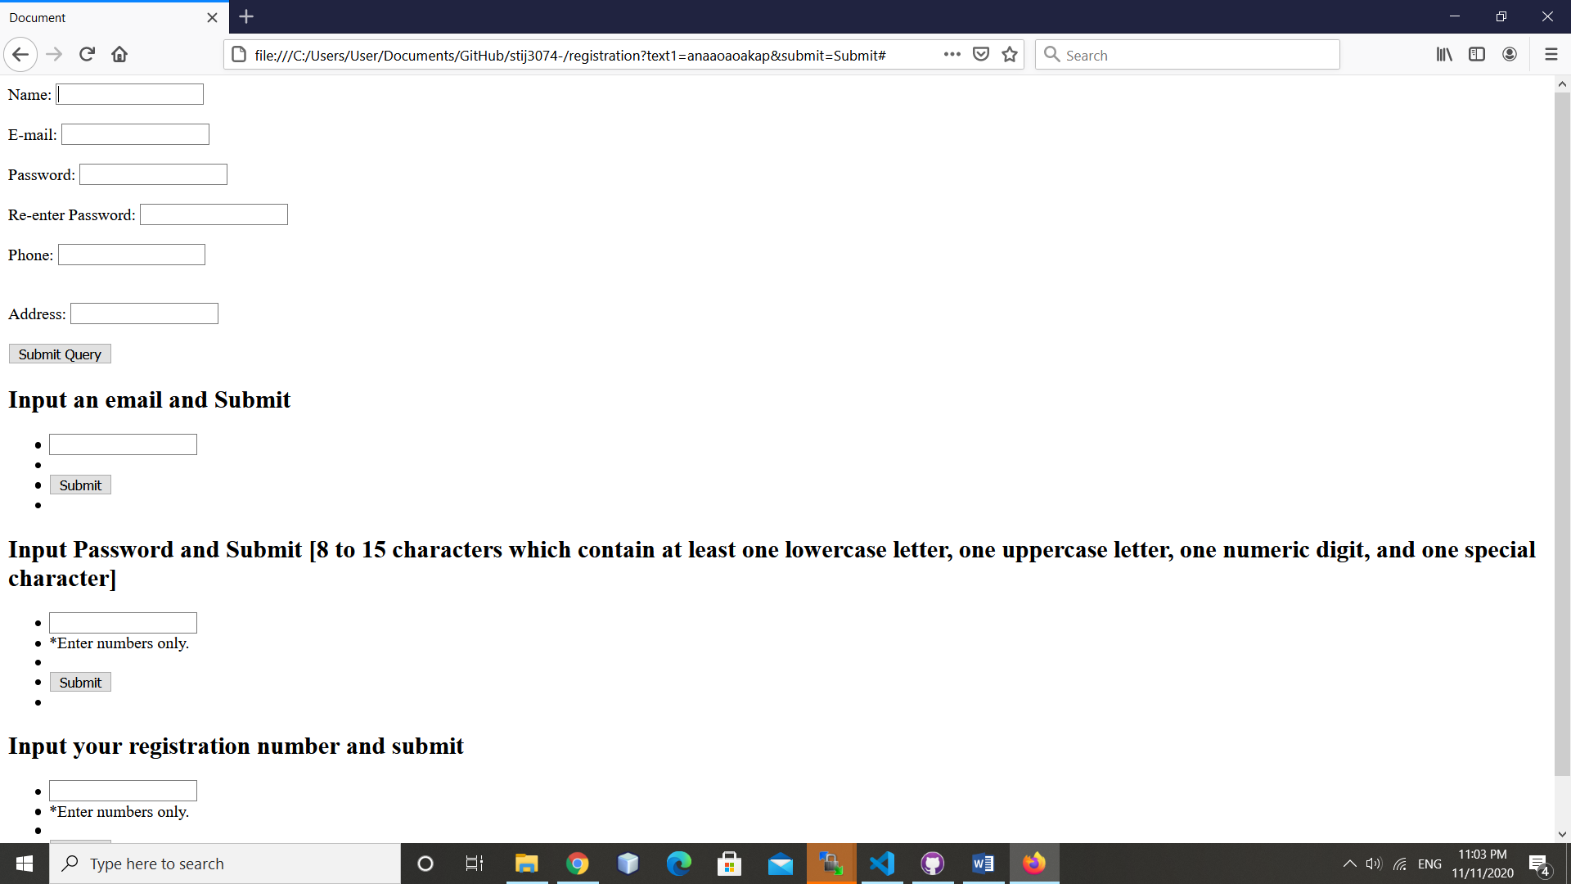

Problem 2

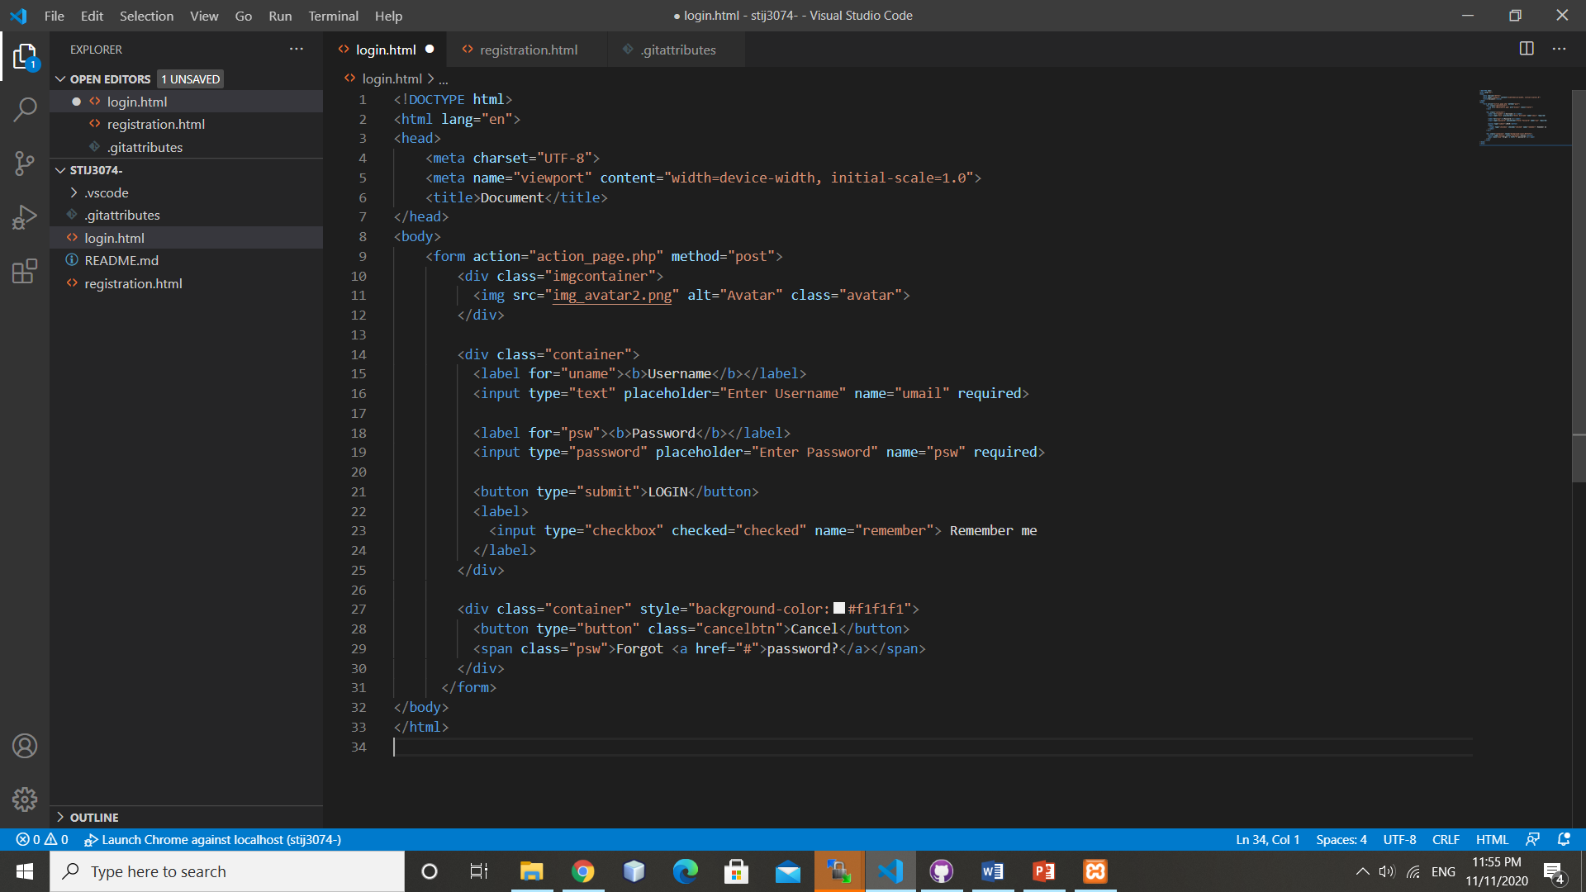

<!DOCTYPE html>

<html lang="en">

<head>

    <meta charset="UTF-8">

    <meta name="viewport" content="width=device-width, initial-scale=1.0">

    <title>Document</title>

</head>

<body>

    <form action="action_page.php" method="post">

        <div class="imgcontainer">

          <img src="img_avatar2.png" alt="Avatar" class="avatar">

        </div>

        <div class="container">

          <label for="uname"><b>Username</b></label>

          <input type="text" placeholder="Enter Username" name="umail" required>

          <label for="psw"><b>Password</b></label>

          <input type="password" placeholder="Enter Password" name="psw" required>

          <button type="submit">LOGIN</button>

          <label>

            <input type="checkbox" checked="checked" name="remember"> Remember me

          </label>

        </div>

        <div class="container" style="background-color:#f1f1f1">

          <button type="button" class="cancelbtn">Cancel</button>

          <span class="psw">Forgot <a href="#">password?</a></span>

        </div>

      </form>

</body>

</html>

